Title of Paper
Forename FAMILYNAME
Instituional affiliation
Abstract
This abtract should be between 100 and 150 words, it should make general statements only and not present or discuss specific data examples. This abtract should be between 100 and 150 words, it should make general statements only and not attempt to present specific data examples. This abtract should be between 100 and 150 words, it should make general statements only and not attempt to present specific data examples. This abtract should be between 100 and 150 words, it should make general statements only and not attempt to present specific data examples. This abtract should be between 100 and 150 words, it should make general statements only and not present or discuss specific data examples.
Keywords: three keywords please
ISO 639-3 language codes: bnq
1. Introduction
To be, or not to be: that is the question: whether ‘tis nobler in the mind to suffer the slings and arrows of outrageous fortune, or to take arms against a sea of troubles, and by opposing end them? To die: to sleep; no more; and, by a sleep to say we end the heart-ache and the thousand natural shocks that flesh is heir to, ‘tis a consummation devoutly to be wish’d. To die, to sleep; to sleep: perchance to dream: ay, there’s the rub; for in that sleep of death what dreams may come when we have shuffled off this mortal coil, must give us pause..
2. Section heading
To be, or not to be: that is the question: whether ‘tis nobler in the mind to suffer the slings and arrows of outrageous fortune, or to take arms against a sea of troubles, and by opposing end them? To die: to sleep; no more; and, by a sleep to say we end the heart-ache and the thousand natural shocks that flesh is heir to, ‘tis a consummation devoutly to be wish’d.

2.1 Sub-section heading
To be, or not to be: that is the question: whether ‘tis nobler in the mind to suffer the slings and arrows of outrageous fortune, or to take arms against a sea of troubles, and by opposing end them? To die: to sleep; no more; and, by a sleep to say we end the heart-ache and the thousand natural shocks that flesh is heir to, ‘tis a consummation devoutly to be wish’d. To die, to sleep; to sleep: perchance to dream: ay, there’s the rub; for in that sleep of death what dreams may come when we have shuffled off this mortal coil, must give us pause. There’s the respect that makes calamity of so long a life; for who would bear the whips and scorns of time, the oppressor’s wrong, the proud man’s contumely, the pangs of dispriz’d love, the law’s delay, the insolence of office, and the spurns that patient merit of the unworthy takes, when he himself might his quietus make with a bare bodkin? There’s the respect that makes calamity of so long a life; for who would bear the whips and scorns of time, the oppressor’s wrong, the proud man’s contumely, the pangs of dispriz’d love, the law’s delay, the insolence of office, and the spurns that patient merit of the unworthy takes, when he himself might his quietus make with a bare bodkin? There’s the respect that makes calamity of so long a life; for who would bear the whips and scorns of time, the oppressor’s wrong, the proud man’s contumely, the pangs of dispriz’d love, the law’s delay, the insolence of office, and the spurns that patient merit of the unworthy takes, when he himself might his quietus make with a bare bodkin?
2.1.1 Sub-sub-section heading
To be, or not to be: that is the question: whether ‘tis nobler in the mind to suffer the slings and arrows of outrageous fortune, or to take arms against a sea of troubles, and by opposing end them? To die: to sleep; no more; and, by a sleep to say we end the heart-ache and the thousand natural shocks that flesh is heir to, ‘tis a consummation devoutly to be wish’d.

2.1.1.1 Sub-sub-sub-section heading
To be, or not to be: that is the question: whether ‘tis nobler in the mind to suffer the slings and arrows of outrageous fortune, or to take arms against a sea of troubles, and by opposing end them? To die: to sleep; no more; and, by a sleep to say we end the heart-ache and the thousand natural shocks that flesh is heir to, ‘tis a consummation devoutly to be wish’d.
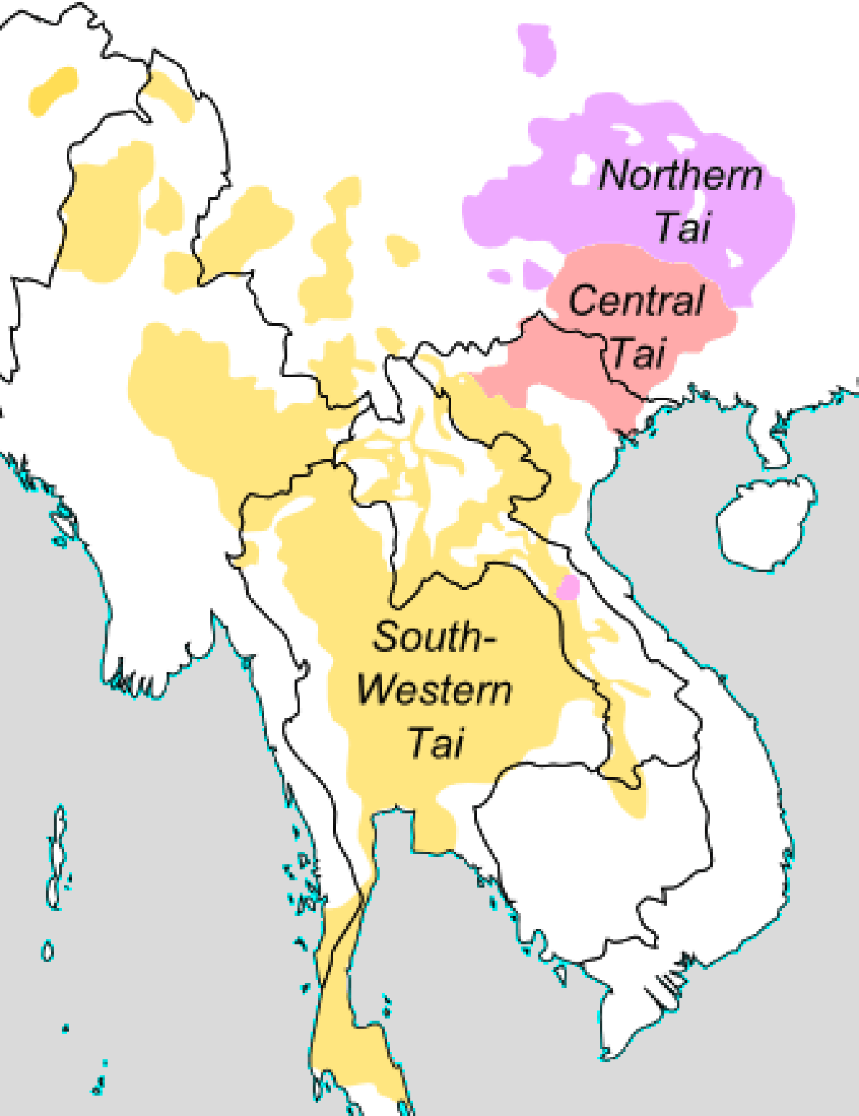
Figure 1: Image 300 DPI colour TIFF fomat
To be, or not to be: that is the question: whether ‘tis nobler in the mind to suffer the slings and arrows of outrageous fortune, or to take arms against a sea of troubles, and by opposing end them? To die: to sleep; no more; and, by a sleep to say we end the heart-ache and the thousand natural shocks that flesh is heir to, ‘tis a consummation devoutly to be wish’d. To die, to sleep; to sleep: perchance to dream: ay, there’s the rub; for in that sleep of death what dreams may come when we have shuffled off this mortal coil, must give us pause. There’s the respect that makes calamity of so long a life; for who would bear the whips and scorns of time, the oppressor’s wrong, the proud man’s contumely, the pangs of dispriz’d love, the law’s delay, the insolence of office, and the spurns that patient merit of the unworthy takes, when he himself might his quietus make with a bare bodkin? There’s the respect that makes calamity of so long a life; for who would bear the whips and scorns of time, the oppressor’s wrong, the proud man’s contumely, the pangs of dispriz’d love, the law’s delay, the insolence of office, and the spurns that patient merit of the unworthy takes, when he himself might his quietus make with a bare bodkin? There’s the respect that makes calamity of so long a life; for who would bear the whips and scorns of time, the oppressor’s wrong, the proud man’s contumely, the pangs of dispriz’d love, the law’s delay, the insolence of office, and the spurns that patient merit of the unworthy takes, when he himself might his quietus make with a bare bodkin?.
Table 1: Image 300 DPI colour TIFF fomat
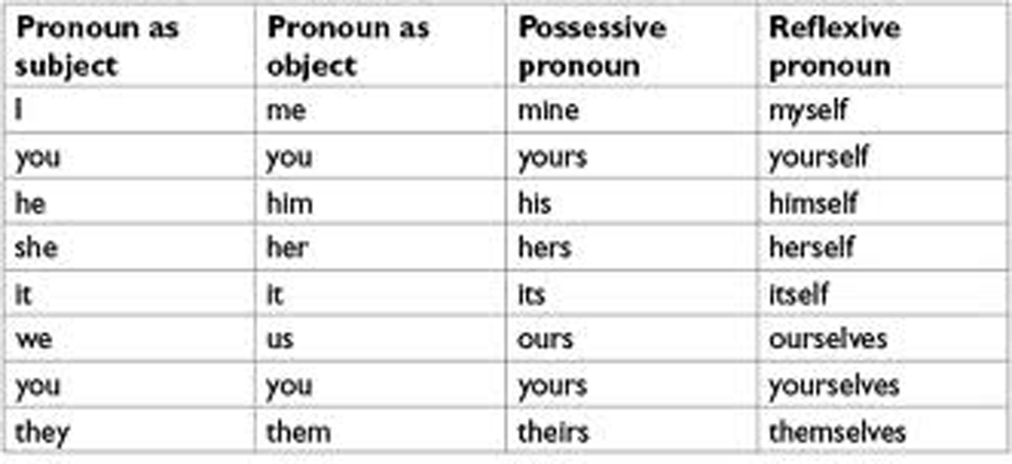
To be, or not to be: that is the question: whether ‘tis nobler in the mind to suffer the slings and arrows of outrageous fortune, or to take arms against a sea of troubles, and by opposing end them? To die: to sleep; no more; and, by a sleep to say we end the heart-ache and the thousand natural shocks that flesh is heir to, ‘tis a consummation devoutly to be wish’d.
(1) gila abur-u-n ferma hamišaluǧ güǧüna amuq’-da-č
now they-OBL-GEN farm forever behind stay-FUT-NEG
‘Now their farm will not stay behind forever.’
(2a) gila abur-u-n ferma hamišaluǧ güǧüna amuq’-da-č
now they-OBL-GEN farm forever behind stay-FUT-NEG
‘Now their farm will not stay behind forever.’
(2b) gila abur-u-n ferma hamišaluǧ güǧüna amuq’-da-č
now they-OBL-GEN farm forever behind stay-FUT-NEG
‘Now their farm will not stay behind forever.’
To be, or not to be: that is the question: whether ‘tis nobler in the mind to suffer the slings and arrows of outrageous fortune, or to take arms against a sea of troubles, and by opposing end them? To die: to sleep; no more; and, by a sleep to say we end the heart-ache and the thousand natural shocks that flesh is heir to, ‘tis a consummation devoutly to be wish’d.
To be, or not to be: that is the question: whether ‘tis nobler in the mind to suffer the slings and arrows of outrageous fortune, or to take arms against a sea of troubles, and by opposing end them? To die: to sleep; no more; and, by a sleep to say we end the heart-ache and the thousand natural shocks that flesh is heir to, ‘tis a consummation devoutly to be wish’d.
(Name year:page)
To be, or not to be: that is the question: whether ‘tis nobler in the mind to suffer the slings and arrows of outrageous fortune, or to take arms against a sea of troubles, and by opposing end them? To die: to sleep; no more; and, by a sleep to say we end the heart-ache and the thousand natural shocks that flesh is heir to, ‘tis a consummation devoutly to be wish’d.
3. Conclusion
To be, or not to be: that is the question: whether ‘tis nobler in the mind to suffer the slings and arrows of outrageous fortune, or to take arms against a sea of troubles, and by opposing end them? To die: to sleep; no more; and, by a sleep to say we end the heart-ache and the thousand natural shocks that flesh is heir to, ‘tis a consummation devoutly to be wish’d.
References
Anderson, Gregory D.S. 2003. Dravidian influence on Munda. International Journal of Dravidian Linguistics 32/1:27-48
Bailey, Charles-James. 2002 (reprint). Essays on Time-Based Linguistic Analysis. Oxford, Clarendon Press.
Bergsland, K., & H. Vogt. 1962. On the validity of glottochronology. Current Anthropology 3: 111-153.
Blood, Henry F. 1966. A Reconstruction of Proto-Mnong (Including Tentative Reconstruction of Proto-South-Bahnaric). M.A. Thesis, Department of Linguistics Indiana University.
Briggs, Lawrence Palmer. 1951. The ancient Khmer empire. Philadelphia, American Philosophical Society

